Simple Machines – 4th Grade
Name(s)________________________ Teacher___________________ Date________

Mission: You and two partners will create a commercial for a fictitious store that sells only one type of simple machine. You will make an advertisement poster that includes information about what your simple machine does and why your machine is the best. It must also include at least five items your store sells. Next, you will write a script for your

commercial. Once you have rehearsed your commercial you will film it with a flip camera and download it to the share drive. Good luck and have fun!
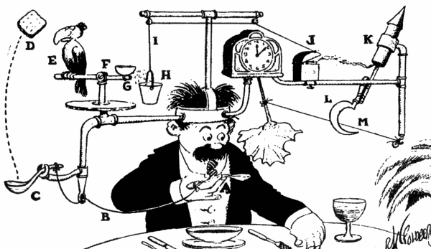
Step 1 – Research the Simple Machines Listed Below
______Inclined Plane ______Screw
______Wedge ______ Wheel and axel
______ Pulley ______Lever

Step 2 – Research the Simple Machines using the online research library icon on the desktop OR your online science book. The questions below will guide you through this process.
What does your simple machine do?
Poster Requirements
- Name of store
- Your simple machine
- Explain how your simple machine works.
- At least five products your store sells.
- Contact information

What is the name of your store?

Why is your simple machine the most useful?

What are some items that use your simple machine to work? Name at least 5.

Simple Machines Commercial Script
____________________________________________________________________________________________________________________________________________________________________________________________________________________________________________________________________________________________________________________________________________________________________________________________________________________________________________________________________________________________________________________________________________________________________________________________________________________________________________________________________________________________________________________________________________________________________________________________________________________________________________________________________________________________________________________________________________________________________________________________________________________________________________________________________________________________________________________________________________________________________________________________________________________________________________________________________________________________________________________________________________________________________________________________________________________________________________________________________________________________________________________________________________________________________________________________________________________________________________________________________________________

