The Roosevelt’s – 3rd Grade
Name(s)________________________ Teacher___________________ Date________

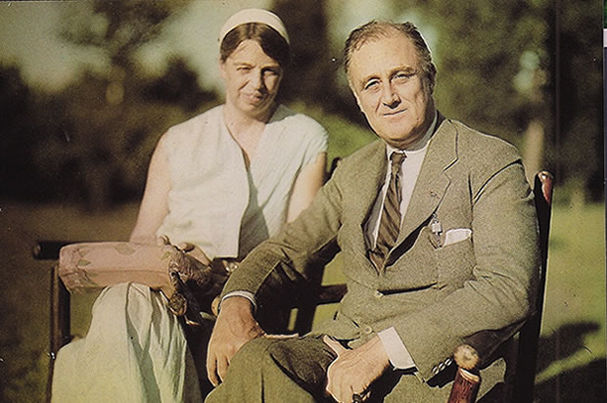
Mission: You and your group will create a paper slide show including paper puppets to tell the story of Franklin and Eleanor Roosevelt. Be sure to include highlights of each of their lives. Use Pebble Go to do the research for your project. Use the note page below to guide your research.

Slide #1 Title Page

Slide #2 – Introduction
Eleanor Roosevelt Facts:_________________________________________________________
_____________________________________________________________________________
Franklin D. Roosevelt Facts:_______________________________________________________
_____________________________________________________________________________
Slide #3 – Early Life
Eleanor Roosevelt Facts:_________________________________________________________
_____________________________________________________________________________
Franklin D. Roosevelt Facts:_______________________________________________________
_____________________________________________________________________________
Slide #4 – Life’s Work
Eleanor Roosevelt Facts:_________________________________________________________
_____________________________________________________________________________
Franklin D. Roosevelt Facts:_______________________________________________________
_____________________________________________________________________________
Slide #5 – Later Years and Contributions
Eleanor Roosevelt Facts:_________________________________________________________
_____________________________________________________________________________
Franklin D. Roosevelt Facts:_______________________________________________________
_____________________________________________________________________________
Slide #6 Credit Page – Include names of who did what and teacher name
Speaker:___________________ Slider:______________________
Teacher:___________________ Camera:____________________

Step 3 – Paper Slide Puppet
Print out a picture of Eleanor and Franklin Roosevelt. Then, cut it out and glue it to a Popsicle stick. These will be the characters that will tell your story.
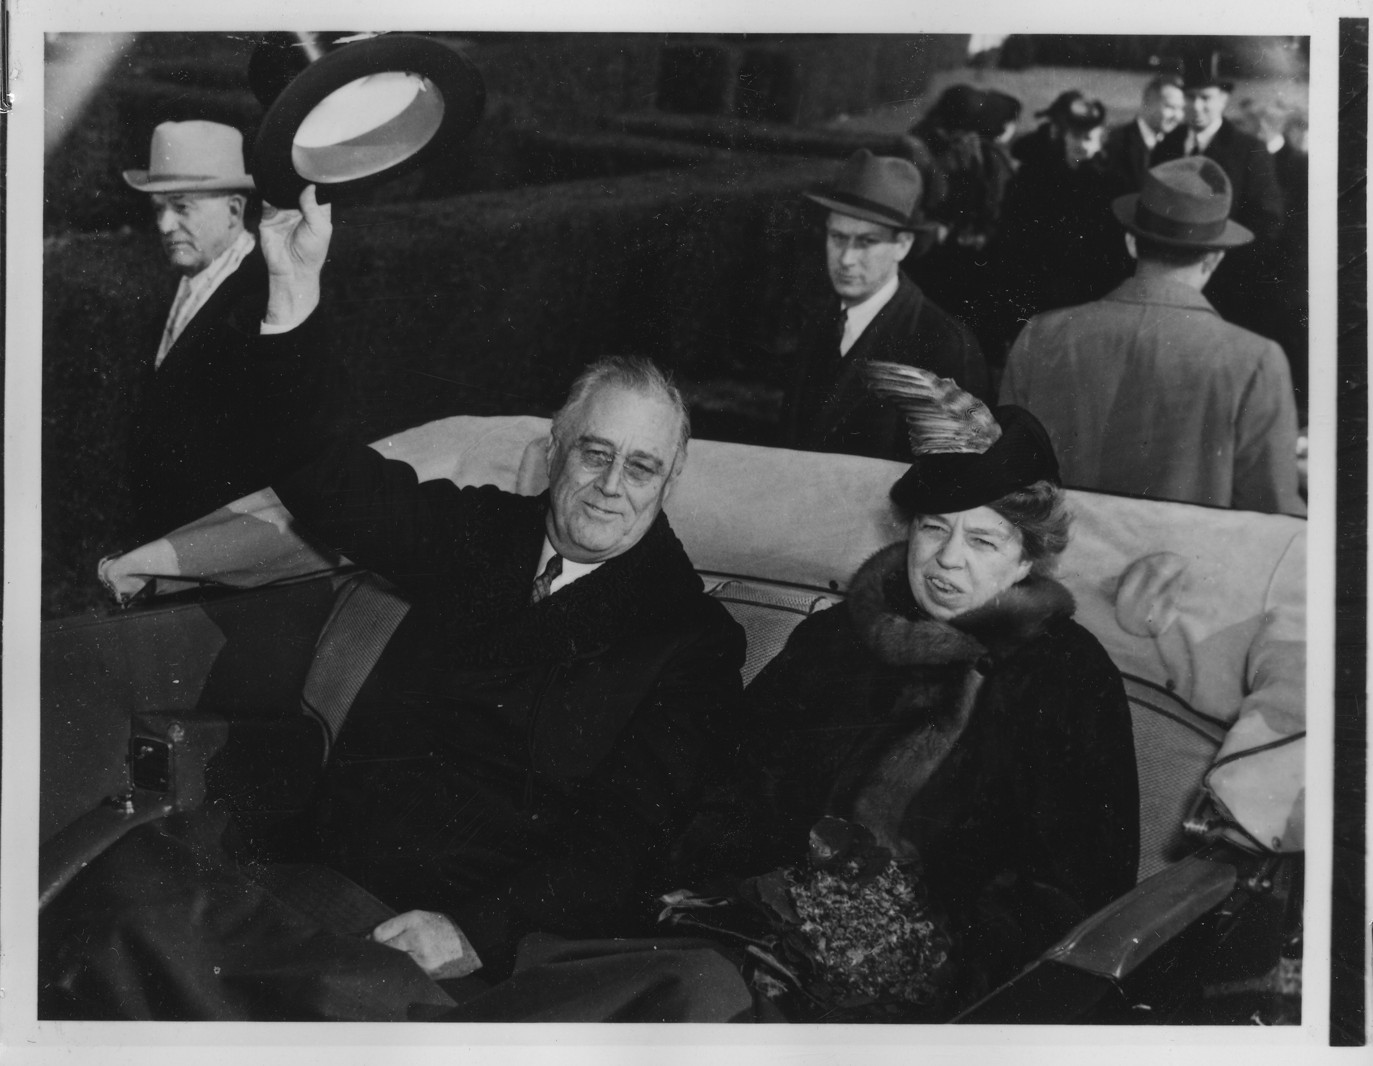
Good Luck and Have Fun!

