Native American Cultures – 4th Grade
Name(s)________________________ Teacher___________________ Date________
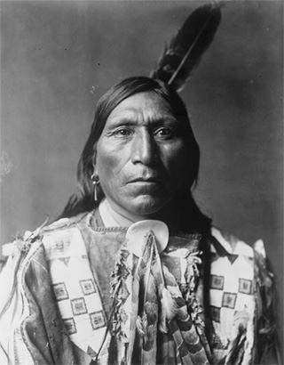
Step 1 – Pick a Culture
______Inuit ______Kwakiutl
______Nez Perce ______ Hopi
______ Pawnee ______Seminole

Step 2 – Research the Native American Cultures using the online research library icon on the desktop. The questions below will guide you through this process.

Slide #1 Title Page

Slide #2
Where do they live?_____________________________________________________________

Slide #3
What type of food do they eat? Why?______________________________________________
_____________________________________________________________________________
_____________________________________________________________________________

Slide #4
What type of clothing do they wear? Why?__________________________________________
_____________________________________________________________________________
_____________________________________________________________________________

Slide #5
What type of housing structures do they live in? Why? ________________________________
_____________________________________________________________________________
_____________________________________________________________________________

Slide #6 Credit Page – Include names of who did what and teacher name

Step 3 – Paper Slide
Create at least 5 paper slides using the information above. Then, use the Flip camera to tell the story of your Native American Culture.

Paper Slide Tips
  - Create a title page at the beginning and a credit page at the end with your names on it.
  - One person holds the camera very still
  - One person moves the slides
  - Each person speaks very clearly into the camera
  - Practice before shooting the Paper Slide Movie

