Famous Americans of the Sixties – 3rd Grade

Name(s)________________________ Teacher___________________ Date________

Mission: You and your partner will research either Thurgood Marshall (Supreme Court Judge) OR Lyndon B. Johnson (U.S. President) for this project. Research the project by using Pebble Go. You will create a Photo Story to demonstrate your knowledge of your person. Use the pictures in the computer lab folder. Save your project to one person’s folder in the student work/computer lab folder.

Answer in Complete Sentences Lyndon B. Johnson
When did he live?  Picture #1  Where did he live?  __________________________________________  __________________________________________  __________________________________________  __________________________________________  __________________________________________  __________________________________________  __________________________________________  __________________________________________ | Introduction  Picture #2  __________________________________________  __________________________________________  __________________________________________  __________________________________________  __________________________________________  __________________________________________  __________________________________________  __________________________________________
Early Life  Picture #3  __________________________________________  __________________________________________  __________________________________________  __________________________________________  __________________________________________  __________________________________________  __________________________________________  __________________________________________ | Early Work  Picture #4  __________________________________________  __________________________________________  __________________________________________  __________________________________________  __________________________________________  __________________________________________  __________________________________________  __________________________________________
Life’s Work  Picture #5  __________________________________________  __________________________________________  __________________________________________  __________________________________________  __________________________________________  __________________________________________  __________________________________________  __________________________________________ | Contributions  Picture #6  __________________________________________  __________________________________________  __________________________________________  __________________________________________  __________________________________________  __________________________________________  __________________________________________  __________________________________________
What do you think the most important thing your person did?  Picture #7  __________________________________________  __________________________________________  __________________________________________  __________________________________________  __________________________________________  __________________________________________  __________________________________________  __________________________________________ | Credit Page – Include your names, your teacher’s name and where you got your information  Picture #8  __________________________________________  __________________________________________  __________________________________________  __________________________________________  __________________________________________  __________________________________________  __________________________________________  __________________________________________

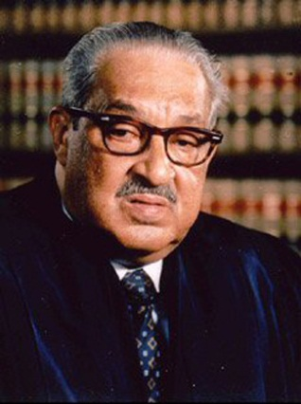
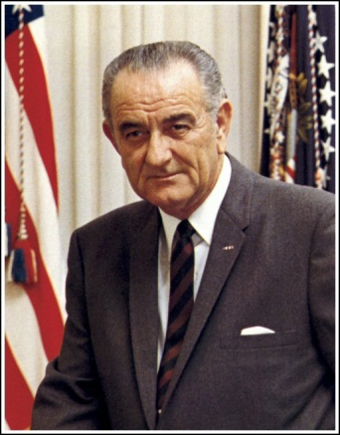

Lyndon B. Thurgood
Johnson Marshall
President of the United States
United States Supreme Court Justice

